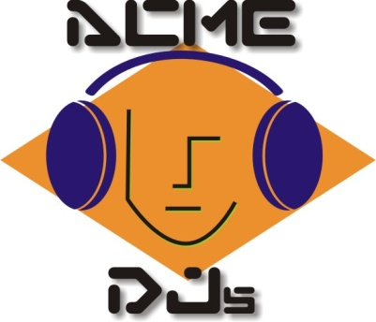

8747 Kirksage Drive Houston, TX 77089 – (713) 444-7798 – fax – (832)900-1051 – www.acmedjs.com

Wedding ReceptionWorksheet

Ushers: ________________________

________________________

Bride’s Parents: ____________________________

Groom’s Parents: ___________________________

Ring Bearer: _______________________________

Flower Girl: ________________________________

Bridesmaids _______________________________ Groomsmen ______________________________

_______________________________ _______________________________

_______________________________ _______________________________

_______________________________ _______________________________

_______________________________ _______________________________

_______________________________ _______________________________

_______________________________ _______________________________

_______________________________ _______________________________

Maid (Matron} of Honor: ______________________________________________________________

Best Man: __________________________________________________________________________

Bride & Groom

Mr. and Mrs. ______________________________________________________

Wedding Worksheet Must be completed and returned Prior To The Reception If we are to make the announcements

Special Dance Information:
First Dance reserved for the Bride and Groom?
Song title and artist: ___________________________________________________________________
____________________________________________________________________________________
Father / Daughter Dance
Song title and artist: ___________________________________________________________________
____________________________________________________________________________________
Mother / Son Dance
Song title and artist: ___________________________________________________________________
____________________________________________________________________________________
Bridal Party Dance
Song title and artist: ___________________________________________________________________
____________________________________________________________________________________
Dollar Dance
Song title and artist:___________________________________________________________________
____________________________________________________________________________________
Boquet Toss song title and artist: ________________________________________________________
Garter Toss song title and artist: _________________________________________________________

Additional Notes:
____________________________________________________________________________________
___________________________________________________________ ________________________
____________________________________________________________________________________

